BUZAPP Lo-fi diagrams

M.Jean-Pierre and Sahib jabbal

University of Kent

|  |  |  |  |
| --- | --- | --- | --- |
| Version Control | | | |
| Version | Author | Comments | Date |
| V1 | Sahib Jabbal | First Version of Document | 23/11/17 |
| QA1 | Marc Jean-Pierre | Reviewed Document | 24/11/17 |

**BuzApp Lo-Fi Diagrams**

**Iteration 2 Lo-Fi Diagrams**

The following Lo-Fi diagrams illustrate the user interface of the BuzApp application.

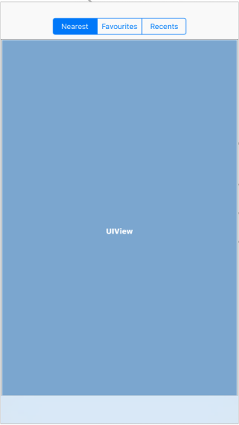

A container that contains the interface for the Nearest, Favourites and Recents tabs

Figure 1-Basic User Interface that allows the user to switch between the segments

A segment control that allows the user to switch between Nearest, Favourites and Recents tabs

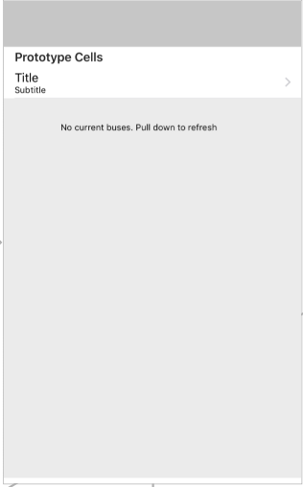

A table view that displays the nearest stops available to the user

A label to be displayed when there are no current buses available as location services of the device is disabled

Figure 2- Nearest bus stops interface

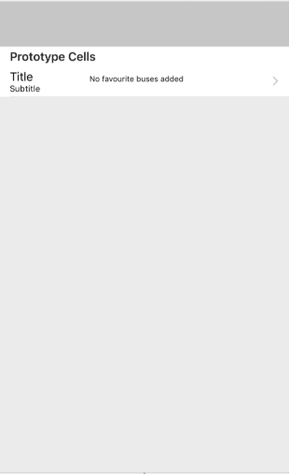

A table view that displays the favourite stops the user has selected

A label to be displayed when there are no favourite buses added by the user

Figure 3- Favourite bus stop interface

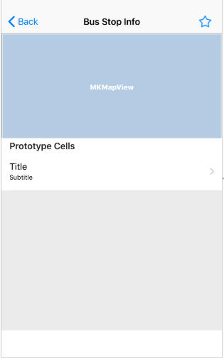

A back button that allows the user to go to the previous page

Allows the user to add the bus stop to favourites

Shows the user the directions to the bus stop from their location

Displays the buses and the time expected

Figure 4- Bus Stop Interface